**A Probabilistic Analysis and Optimization of Blackjack Strategy: A Simulation Study**

ISyE6644 Fall 2021 Course Project

*Members:* Kevin Stone

**Abstract**

The well-known optimal Blackjack strategy is herein analyzed via probabilistic simulation, and the effects on player value / house edge are reported in detail. The simulation and analysis were conducted in Python, and the quantitative results are presented for 12 major variations and 13 minor variations of optimal strategy and game rules, after more simulating more than 500 million hands altogether. Basic descriptive statistics and informative figures are provided for each strategy: including the PMF and CDF, value-over-time, outcomes histogram, and a heatmap of realized card-value combinations. In total, these statistics show how and why the house edge can be reduced from 8.2 to 0.1% with the application of optimal strategy and for different sets of common rules. Furthermore, the simulation program is leveraged to validate the popular optimal strategy and re-optimize for different variations. A meta-analysis of these results reveals that greater than 90% of the value in optimal Blackjack strategy can be condensed to five simple clusters of “rules,” greatly simplifying its application in practice. All of the software has been written for interaction with a public web application, where any user can recreate the conclusions herein.

**Background**

Out of nearly every game that can be played in a casino, Blackjack famously has one of the lowest possible values for the “house edge” – that is, the expected value returned to the casino for each hand. Depending on local rules, the house edge for Blackjack lies between 0.2 and 0.5%[1-3]. Inversely, this can be interpreted as the highest expected return to the player, 99.5-99.8% per hand. Fortunately, this is a relatively high return for the player compared to similar card games: 0.5-7% on variations of Poker, 1-17% on Craps, and up to 15% on slot machines[1]. Furthermore, the mathematically optimal Blackjack strategy is well-documented, legal, and even welcomed into casinos with a popular cheat-sheet index card. Notably however, no popular casino rules allow for any strategy to their house edge to decrease below 0%, which would imply an expected value in favor of the player winning money on average. Even in the most favorable game, the house always wins (in the long run). Only with frowned-upon yet still-legal strategies of card counting or collusion between players, and only in certain instances, can the house edge be decreased as low as -1.5%[4]. The question might become pertinent then – *why does anybody bother playing Blackjack, or gambling at all for that matter*? Of course, the answer is very likely in the appeal of the non-zero probability of short-term winnings.

So, what is the short-term probability of winning a hand of Blackjack? How likely is any player to walk away with doubling their money, and after how many hands played? How do the different elements of “optimal strategy” contribute to improving these odds? And of all of the “optimal” reactions, which ones are the most valuable? These are the questions that we seek to answer with this study, and we will approach it with Monte-Carlo simulation executed in Python.

An object-oriented program was written in Python (~500 lines) to iteratively simulate Blackjack using only common libraries such as Pandas, Numpy, Random, and Plotly. A separate application was written in Python using Streamlit and deployed publicly at <http://blackjack-strategy-simulator.herokuapp.com/>. This web app communicates with the base program and allows for detailed, complex user interaction. All of the figures included in this report (plus many more) can be generated using the web app functionality. Of note, users may upload entirely custom Blackjack strategies and test them there with all of the statistical analysis utilities developed. Figure 1 depicts a pseudo-code infographic for the various objects, their attributes, and their methods necessary to perform these simulations. Appendix C offers an alternative perspective, with a mathematical formulaic depiction of the game.

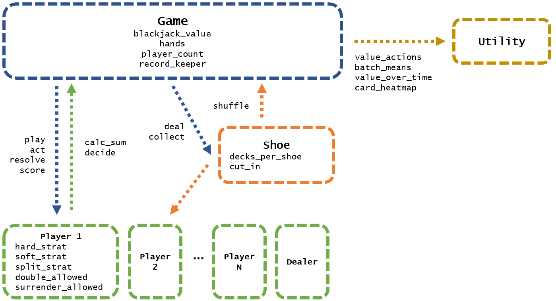

*Figure 1: Pseudo-code for the Blackjack strategy simulator and analysis*

Most of the important details lie in the *act, decide,* and *resolve* methods of the game object since we are most interested in exploring how different strategies (actions informed by player cards and the dealer card) lead to different outcomes. Player strategies are loaded in with Excel files, which have been built from variations of the well-published optimal/basic blackjack strategy (see Appendix B for more details). Therefore, the player decisions amount to a look-up value based on these preloaded tables and three conditions: the player’s cards, the dealer’s one showing card (upcard), and game dynamics informed by applicable rule variations (e.g. whether or not doubling or surrender are allowed, or doubling-down after a split). As mentioned briefly before, the code is also built to accept completely custom strategies that are assembled in an appropriate format in Excel files. Once a suitable number of hands are simulated (at least 500,000 for stable results), various statistical analyses are performed on the compiled results in the game’s *record_keeper* attribute. In this way, we can break down optimal Blackjack strategy to its major components (hard totals, soft totals, and splits) and relate these strategic elements to changes in the outcome probabilities, for various iterations of different popular Blackjack game rules.

All of the simulations discussed are deemed to be statistically sound based on their ability to support or refute the desired hypotheses within the 95% confidence bounds around the sample means. The primary approach employed herein was a simulation of 100,000 hands replicated 100 times for a total of 10MM total games. The variance of an individual hand is very high, so that the sample means don’t converge tightly enough until the number of hands is above approximately 50,000. Of course, 100,000 hands would take a very long time to play; but the intention of this approach is to evaluate long-term averages not the distribution of short-term games for comparing strategy. To answer the latter inquiry, we have also conducted a separate style of simulation, running at least 10,000 iterations of 100 hands (approximately 2 hours of play). Both approaches are necessary and validated for their intended use as they appear throughout this report.

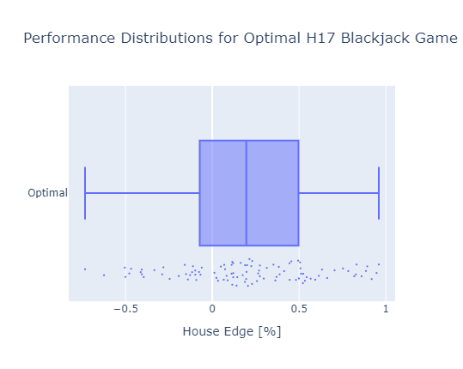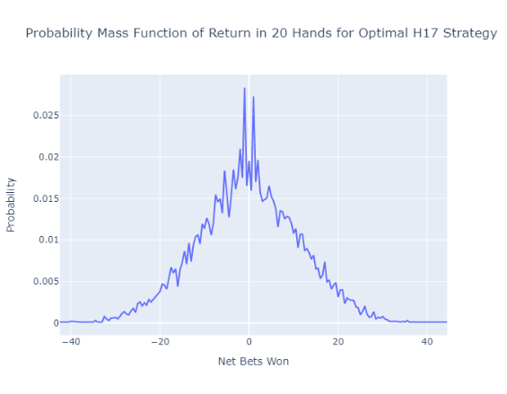

*Figure 2 (Left): Box plot for 100 replications of 100K hands*

*Figure 3 (Right) PMF for return in 100 hands over 10K replications*

The last component of this report takes this approach one step further using the same code structure. If we can easily simulate many thousands, even millions of Blackjack hands quickly (approximately 1 msec/hand), we should also be able to validate the optimal Blackjack strategy with this code. More importantly, we can regenerate these popular “strategy cards” for any different variation of the game at our leisure. Perhaps the most interesting element of this approach is that we can further examine not only what each best action is, but what the *value* is for that action. That is, we can determine how much more an action is worth (weighted by the probability of each situation) relative to the default (or dealer’s) action. As this report will show, although one action is always best, sometimes this action and the default action are approximately equal in value. Most of the value of the optimal strategy, therefore, can actually be reduced to a surprisingly low number of distinct and easily-memorized rules. The value of this observation could be tremendous, certainly for players in casinos where the strategy cards are not allowed at the Blackjack tables.

**Main Findings**

To illustrate the impact of various elements of the optimal Blackjack strategy, the decision tables were broken down into 5 distinct parts:

*With Double-Down and Surrender Disabled…*

1. Hard Sum Strategy : What is the total (hard) sum of the player’s cards?
2. Soft Sum Strategy: If the player has an ace that can be counted as 11, what is the sum of the other cards?
3. Split Strategy: If the player has two cards of equal value, what is the value of the pair?

*Otherwise…*

1. Full optimal strategy, Double-Down enabled
2. Full optimal strategy, Double-Down and Surrender enabled

Each of these three key strategy elements require a player to examine some property of their cards, the dealer’s one card showing (the “upcard”), and find the corresponding action on the strategy tables. The recommended actions will be one of the following:

1. Hit: Request another card, can be done until the sum exceeds 21 (bust)
2. Stand: No action, immediately seek to resolve the hand with the dealer
3. Double Down: Hit only once, and double the value of the bet
4. Split: Split two cards of equal values into two distinct sets, hit each set once and continue to act on them independently
5. Surrender: Do not resolve the hand with the dealer, accept a loss at half of the bet’s value

Slight variations of rules might occur, such as not allowing Double Down or Surrender. Accordingly, each case is examined in this simulation study. Some different rules exist for Splitting - such as disabling the splitting of pair Aces, or not allowing sequential splits. For the purposes of this study, splitting Aces was allowed and a maximum of 3 sequential splits could be conducted (only if the first two cards in each set qualify). The most common rule variation which affects the player outcomes is the dealer’s strategy. In all cases, the dealer must always follow a fixed set of decisions, which always includes hitting until a sum of 17 or greater is reached before standing. The rules vary, however, on soft 17s (that is, an Ace and a set of other cards adding up to 17). In some cases, the rules demand the dealer hits on Soft 17 (H17 game) and others demand the dealer stands on Soft 17 (S17 game).

The three variations of optimal strategy, doubling down, surrendering, and dealer strategies lead to 12 variations of optimal strategies and rules that were analyzed via simulation. Each simulation was conducted with sets of 6 players “at the table” together for 10 million hands in sets of 100,000. The value of a Blackjack was fixed at 3/2 (that is, obtaining a blackjack returns a value of 1.5 bets to the player) as is standard. The results of each strategy are summarized in Table 1 (S17) and Table 2 (H17). The long-term impact is summarized by the house edge (includes all 10 million hands). The short-term impact is analyzed by splitting the simulation in 20-hand batches and examining the fraction which return 5 or more net bets won.

*Table 1 (Top) and Table 2 (Bottom): Incremental Gains from Strategy & Game Options*

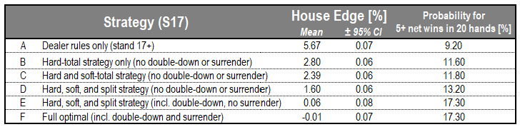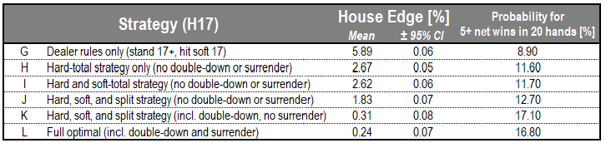

*\*All results generated from 10MM hands in 100K sets. Blackjack value = 1.5, dealer hits on Soft 17, 4/6 decks cut-in,*

*max splits of 3, double-down after split, re-hitting split aces, and re-splitting split aces (unless otherwise stated)*

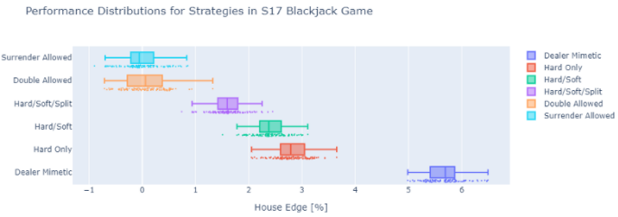

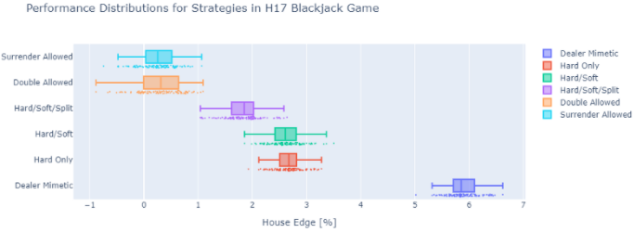

*Figure 4 (Top) and Figure 5 (Bottom): Box plots showing performance distributions for all 12 strategies*

Each of these 12 strategies can be examined through the lens of four helpful figures shown in Figures 6 through 9. As an example, Figure 6 shows the player value over time for Strategies A through F (in terms of unit bets) throughout the whole simulation. A visible amount of noise is present as expected (player value randomly increasing/decreasing in the short-run), but the generally linear behavior for each strategy is evident after approximately 100K iterations.

Figure 7 shows, with histograms, the breakdown of hand outcomes for each player with Strategies A through F. Note the horizontal hash mark on some sets of the bars, which separates the results experienced while “Doubling Down” (above the hash) from the bets of regular value (below the hash). The first strategy in each set never Doubles Down, as this is not representative of following baseline dealer strategy. In this figure, it is also clear how the enabling of the Surrender strategy improves player odds. When surrender is allowed (last player in each set), the frequency of busting (exceeding 21) is greatly reduced. Also noteworthy is that no strategy impacts the probability of a Blackjack, which remains at approximately 4.5% independent of optimal strategy – for both the player and dealer.

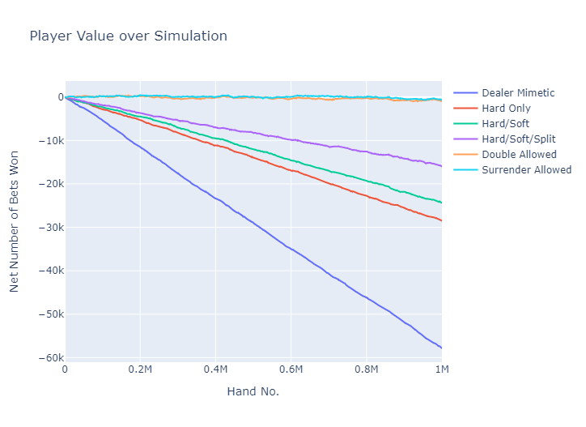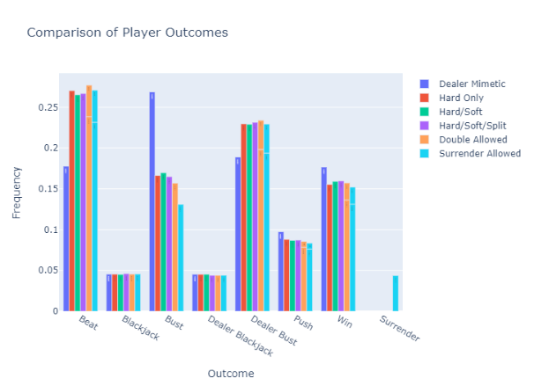

*Figure 6 (Left): Player Value over Time (Net Bets) vs. Player Strategies A through F*

*Figure 7 (Right): Histogram of Bet Outcomes vs. Player Strategies A through F*

Figure 8 provides an example for the Probability Mass Function for each Strategy G through L. On the independent axis is the number of net bets won in a set of 20 hands. On the dependent axis is the corresponding probability extracted from 50K replications of these 20 hands. As expected, this is not a continuous function; and there are peaks at each integer value of net bets won. Significant valleys between the peaks lie at half-integer values due to the introduction of Blackjack (1.5 bets won) and Surrender (0.5 bets lost). The PMF for all strategies can be seen visually to have a mean slightly lower than zero, as this is representative of the strictly positive house edge.

Lastly, Figure 9 shows the transformation of the PMF which is the Cumulative Distribution Function – the probability that at least X value is attained integrating the PMF from negative infinity to X. It is from this figure that the short-term probability of returns is easily interpreted. For example, note that most strategies lead to a probability of 10-15% of walking away from a set of 20 hands with a net of 5 or more hands won. This indeed is the attraction to gambling, that the player hopes to attain this probability in their sequence of gambling. Different sized sets-of-hands can be analyzed through the web application. The important distinctions between these results, concerning incremental return to the player based on improvements in strategy, will be discussed in the following section.

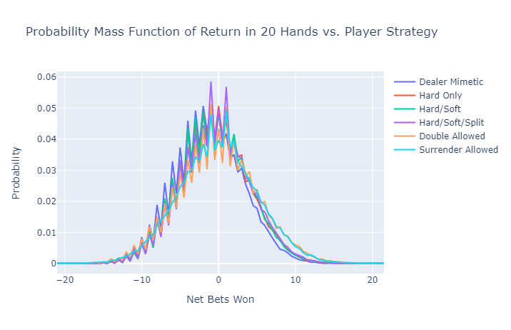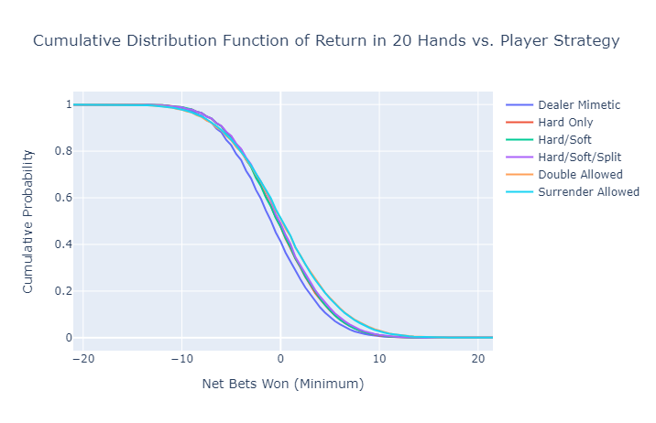

*Figure 8 (Left): PMF of Net Bets Won in 20 Hands vs. Player Strategies G through L*

*Figure 9 (Right): CDF of Net Bets Won in 20 Hands vs. Player Strategies G through L*

In addition to simulating the performance of bulk strategies, we can use this simulation paradigm to simulate actions on the individual level – for example, with a dealer upcard of 7 and a player hard sum of 17, what would be the expected outcome of hitting, standing, doubling down, et cetera? The actual incremental value of the optimal actions is not well-described by common literature on optimal Blackjack strategy, but it is within reach of this simulation study.

Figure 10 shows a summary of the best actions determined from 10K simulations of each player/dealer card combination which serves as a validation of the popular reported “optimal strategy”. Different from the typical report, however, is the color plotted on the z-axis. Here, an expected value is determined for each action (average over all iterations) relative to the action that the dealer would have taken (simplest possible strategy). This differential expected value is then multiplied by a probability – the probability of encountering that combination in the first place. The end result can be considered as the *true value* of taking this optimal action instead of defaulting to the dealer’s action.

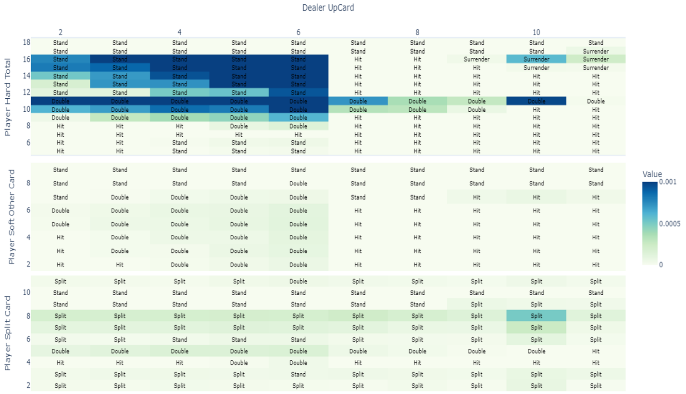

*Figure 10: Optimal strategy for H17 game, with probability-weighted differential value from dealer action*

There are several differences between these simulation-derived “best actions” and those of the common “optimal strategy.” However, it is remarkable that in all of these cases, the probability-weighted incremental value is near-zero. That is to say, the choice of optimal strategy is not expected to truly matter, relative to the default choice. It is possible that with more iterations, the two would agree perfectly, or that the optimal strategy table was simplified for readability based on a similar observation (put Stands next to Stands, Hits next to Hits, if expected value is otherwise not significantly different). At any rate, we find that the differences do not matter. For all of the values which are significantly non-zero (even slightly colored in Figure 6), there is a perfect match with optimal strategy.

**Conclusions**

After simulating all twelve variations of strategy and rules (A through L), a summary of the effects of each can be assembled by taking the average result with/without the variation enabled, holding all else equal. The average effects are summarized in Table 3, with a result each for long-term effects (average house edge in 100K simulations) and short-term effects (probability of >5 net wins in 20 hands via batch means analysis).

*Table 3:Average effects of strategy and rule variations*

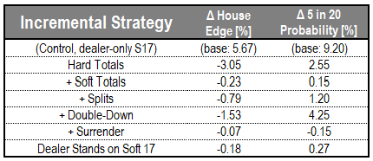

*\*All results generated from 10MM hands in 100K sets. Blackjack value = 1.5, dealer hits on Soft 17, 4/6 decks cut-in,*

*max splits of 3, double-down after split, re-hitting split aces, and re-splitting split aces (unless otherwise stated)*

For both short and long term effects, the most beneficial piece of strategy is the “hard sum strategy” which offers ~3% decrease in house edge. Allowing double-down is the next most impactful change that can be made. The effect of this is especially important for short-term winnings – whereas doubling-down only decreases the house edge by a relative 25%, it tends to increase the short-term odds of winnings by nearly 40%. Next, splitting strategy and soft strategy offer smaller but yet significant improvements to player returns. As is evident between Figures 4 and 5, the inclusion of soft strategy is most important in the Dealer S17 game. In the H17 game, the dealer consumes most of this edge that is otherwise available to the player in the S17 game, based on optimal decisions for soft hands. The impact of allowing surrender is the least effective of all and interestingly decreases the overall variance of our outcomes. Last, we have examined the impact of dealer behavior to find that standing on soft 17 (less common) offers a mild benefit to the player, albeit only fractionally valuable relative to the application of overall optimal strategy (hard/soft/split/double).

In summary, the value of piecewise strategy or rule changes can be summarized as follows:

Hard Sums > Double Down > Splitting > Soft Sums > Dealer Standing on Soft 17s > Surrender

We can explain this pattern by examining the frequency of outcomes in the simulation. For the sake of example, Figure 11 will show these results for Strategies G through L. For the first player, mimicking the dealer, the substantial house edge is gained because the player may bust before the dealer ever reveals his cards. Therefore, this strategy leads to significant odds for the player busting, and substantially less so for the dealer busting. The inclusion of hard-sum strategy therefore leads to a crucial increase in performance by avoiding a player bust. Rather than always hitting on hard 16s and lower, this strategy evens the odds for the player by only risking the hit if the dealer upcard is greater than 6 (for a hard player sum of 13 through 16). The decrease in the “bust” outcome is replaced by increases in the “beat” outcome, but more importantly accompanied by a major increase to the “dealer bust” result.

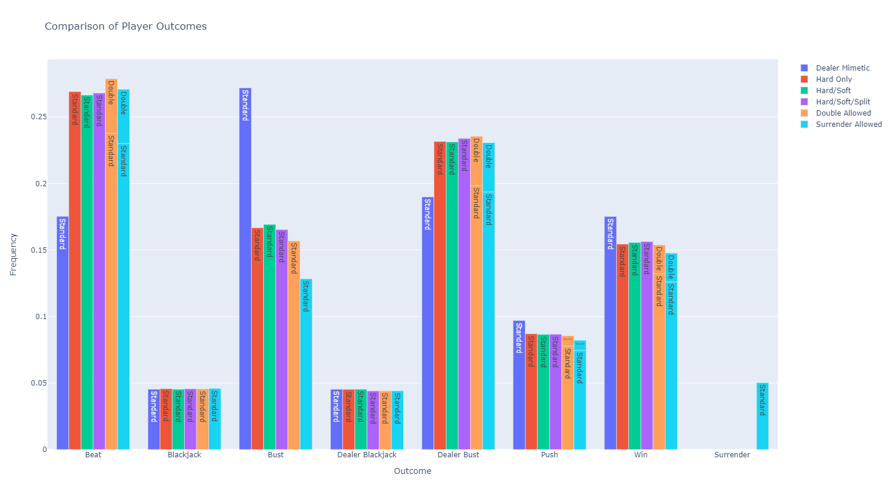

*Figure 11: Histogram of Bet Outcomes vs. Player Strategies G through L*

The impact of doubling-down can clearly also be seen in the figure (events with the double-down circumstance above the white hash on each bar). It is noteworthy that most double-down actions lead to a result of “dealer bust” or “win,” with a smaller fraction on “beat” and “push.” The simple interpretation here is that a lot of value can be gained by doubling the bet for scenarios with a high-likelihood of winning. By taking advantage of those situations, a player may dramatically improve his or her returns.

The effect of including soft-sum and splitting strategy is much more subtle, as expected. Only modest improvements to the beneficial or neutral results “win,” “dealer bust,” and “push” can be observed. In both cases, a consistent increase is seen in the “dealer bust” result as with an decrease in the player “bust” result. This serves as a lucid reminder that winning Blackjack is not as much about “getting to 21” as it is simply beating the dealer, which includes taking advantage of the rules and probability to let the dealer bust.

The impact of surrendering is far more obvious. The frequency of surrendering is surprisingly high, although there are only 4 recommended opportunities for this, because those card combinations are particularly probable. Figure 11 is once again quite helpful to determine that the realized gains come from reducing the frequency of “beat” or “bust.” Either of these outcomes would lead to net loss of 1 bet, whereas surrendering mitigates this to a loss of 0.5. The high frequency of this event actually grants this strategy a meaningful impact.

Another particularly interesting result is the very significant short-term impact of doubling down. After all, a smart players know the long term odds are stacked against them; so the rational desire should be to increase the short-term gains. In that sense, knowing when to double down appears to be more important than knowing all of the hard-sum strategy (see Table 3). Of course, this makes sense because we are effectively doubling the variance of a certain domain. With a higher variance, we would certainly expect a wider range of the PMF. Furthermore, since we know only to double down on events with good odds, we steer the average of this distribution in our favor. Indeed, we can see in our PMFs (Figure 12) that the short run variance (20 hands played) is increased (slightly wider PMF) with allowing double-down. Over longer horizons (100 hands played) the change in variance (proportional to the width of the PMF) becomes less distinguishable, but the mean of the PMF becomes noticeably shifted right (player-favorable).

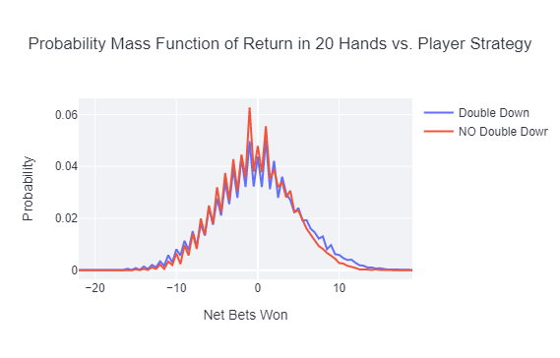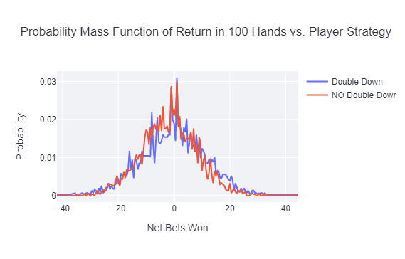

*Figure 12: Short (Left) and Long-Term (Right) PMFs with and without Double-Down enabled*

Apart from the common strategy and rule variations described above and in Table 3, we can further simulate the effects of some possible, but less common rule changes. As shown in the results summary of Table 4, the most important rule changes relate to the value of the Blackjack bonus. Astute players would best avoid games that offer less than 3/2. Further, the disabling of re-hitting split aces and doubling-down after split are relatively important (increasing the baseline house edge by 122% and 54% respectively). The rest of these minor rule changes are found to not have a particularly distinguishable effect (at least in the high but imperfect confidence offered by 10 million simulations in 100 batches).

*Table 4:Average effects of less common and minor rule variations*

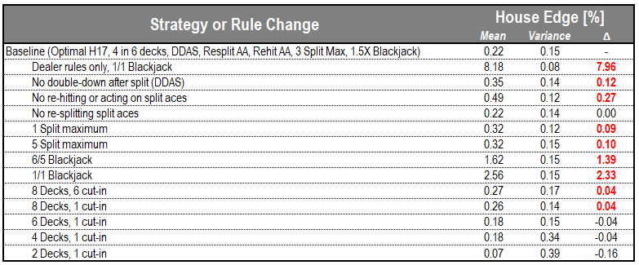

*\*All results generated from 10MM hands in 100K sets. Blackjack value = 1.5, dealer hits on Soft 17, 4/6 decks cut-in,*

*max splits of 3, double-down after split, re-hitting split aces, and re-splitting split aces (unless otherwise stated)*

The last and most important conclusion to be made from this simulation study is the potential reduction of optimal strategy based on our probability-weighted differential action analysis (Figure 10). It is readily evident that the most valuable actions reside in clusters on this diagram. Perhaps, we can therefore simplify the entirety of the very large strategy table to a small subset of important rules. We can even take the flexibility to violate the “optimal actions” to make simpler rules, if we know that the suboptimal action is not impactful according to Figure 10. Here is one possible digestion of optimal strategy into only five concise rules (in order of importance):

*Table 5: The Top 5 Most Profitable Rules in H17 Blackjack*

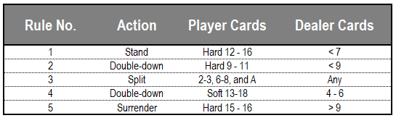

Amazingly, with just these five rules, we find almost identical performance to the optimal strategy. With a simulation of 10 million hands, we find that the 5-rule concise strategy covers more than 90% of optimal value, and amazingly 87.5% of the value with only 3 rules.

*Table 6: Incremental concise 5-rule strategy versus optimal strategy*

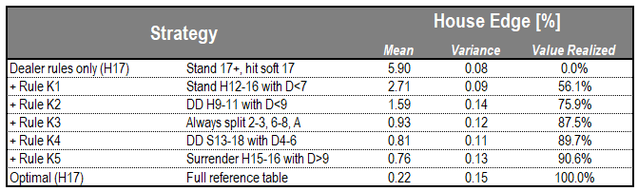

*\*All results generated from 10MM hands in 100K sets. Blackjack value = 1.5, dealer hits on Soft 17, 4/6 decks cut-in,*

*max splits of 3, double-down after split, re-hitting split aces, and re-splitting split aces (unless otherwise stated)*

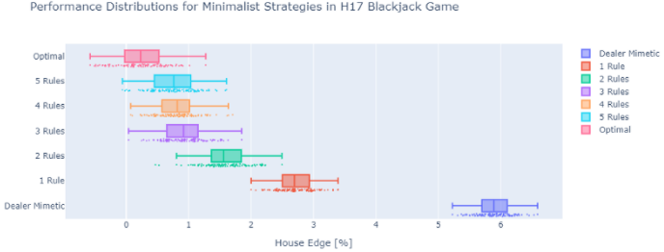

*Figure 13: Performance distributions for 1- to 5-rule minimalist strategy versus optimal strategy and baseline dealer strategy*

The implications of the simplification are quite important. Some casinos do not allow players to bring an “Optimal Strategy” cheat sheet to the table, and memorizing that entire table is a difficult task. On the other hand, we can get greater than 90% of the value for all optimal strategy just by following these 5, easily-memorized rules.

Although the house-edge of optimal strategy (0.22%) is more than 3 times improved on the 5-rule strategy (0.76%), this is an effect only realized over very long horizons. To the casual gambler, perhaps only playing 100 hands over the course of 2 hours, the short-term effect of these strategies is far less significant. Figure 14 below shows the relevant PMF and CDF for this situation, which can hardly be distinguished between the optimal and minimalist strategies. The CDF shows quantitatively that the odds of winning between 5 and 10 wins in the 20-hand run are only 6% higher for full-optimal play. That’s just a six percent improvement in 100-hand performance for memorizing an additional 20 rules, approximately. For most casual players, this could be a game-changing simplification.

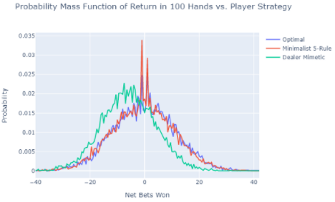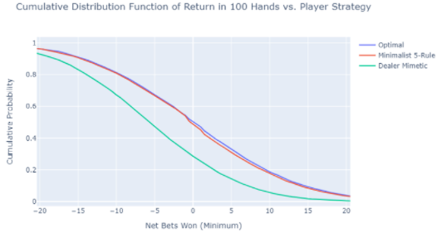

*Figure 14: The PMF and CDF of Returns in 100 Hands for optimal, minimalist 5-rule, and dealer-only strategies*

In summary, this report has quantified and elaborated on the incremental effects of various elements of optimal Blackjack strategy. Appendix D provides even more detail through each of the important figures for all 12 strategies in consideration. Although not directly discussed in this report, Appendix E offers another interesting look into card-value combinations with a heatmap constructed on the realized-value of cards in a simulation of optimal strategy. Last, a meta-analysis of the optimal strategy uncovered the possibility for an important simplification of optimal strategy to 5 simple rules that are capable of realizing 90% total value of perfect play.

All of the figures presented here are available for recreation on the public web application at <http://blackjack-strategy-simulator.herokuapp.com/>.

**Appendix A: References**

1. Michael Schackleford. “House Edge of Casino Games Compared.” The Wizard of Odds. <https://wizardofodds.com/gambling/house-edge/>. Accessed 03 November 2021.
2. Henry Tamburin. “How to Further Reduce the House Edge.” *The Ultimate Blackjack Strategy Guide,* 888 Casino. <https://www.888casino.com/blog/blackjack-strategy-guide/blackjack-odds-how-to-further-reduce-the-house-edge#:~:text=By%20adding%20the%20value%20of,a%200.5%25%20casino%20edge>. Accessed 03 November 2021.
3. “Blackjack Odds.” Mr Green Ltd. <https://www.mrgreen.com/en/blackjack/strategies/blackjack-odds>. Accessed 03 November 2021.
4. Bradley Retter. “Interested in Advantage Gambling? Start With Card Counting.” Best US Casinos. <https://www.bestuscasinos.org/blog/advantage-gambling-start-with-card-counting/>. Accessed 03 November 2021.
5. Colin Jones. “Learn Blackjack Strategy.” Blackjack Apprenticeship. <https://www.blackjackapprenticeship.com/blackjack-strategy-charts/>. Accessed 03 November 2021.
6. Michael Schackleford. “4-Deck to 8-Deck Blackjack Strategy.” The Wizard of Odds, 13 August 2019. <https://wizardofodds.com/games/blackjack/strategy/4-decks/>. Accessed 03 November 2021.

**Appendix B: Optimal Blackjack Strategy[6]**

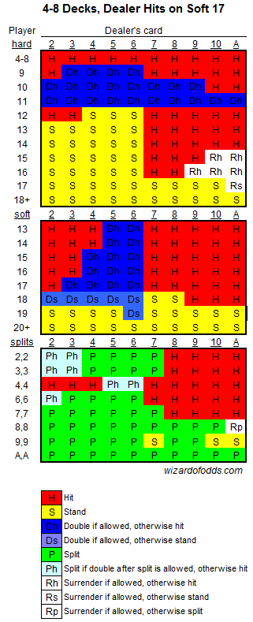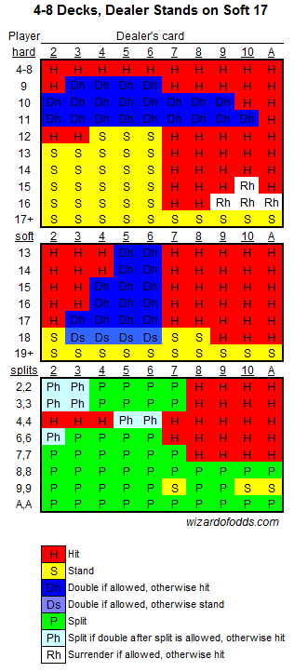

**Appendix C: Mathematical Representation of Blackjack**

*Equation B1: Expected value with LOTUS (general form)*



*\*

*Equation B2: Expected player return based on dealer/player cards*



*Equation B3: The player return function based on the outcome (h) of dealer/player cards*



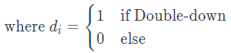

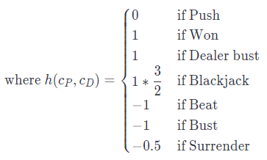

*Equation B4: House Edge in terms of expected player return*



**Appendix D: Comprehensive Figures for Each Strategy:**

**Strategies A-F (Dealer Stands on Soft 17)**

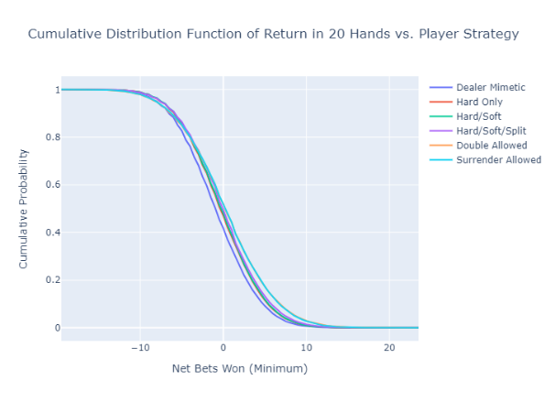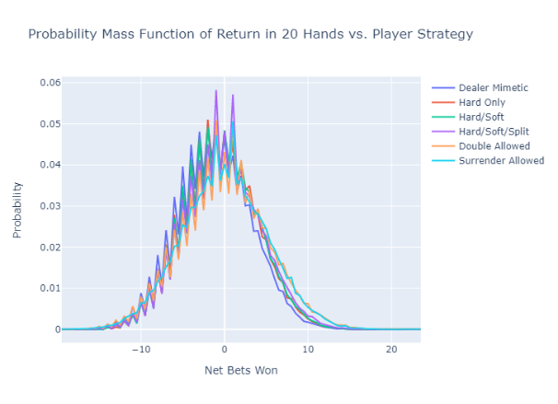

**Strategies G-L (Dealer Hits on Soft 17)**

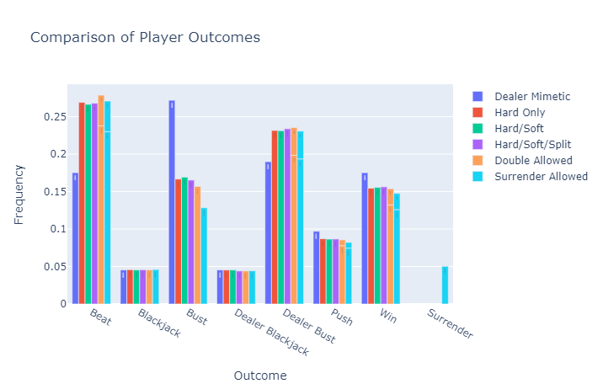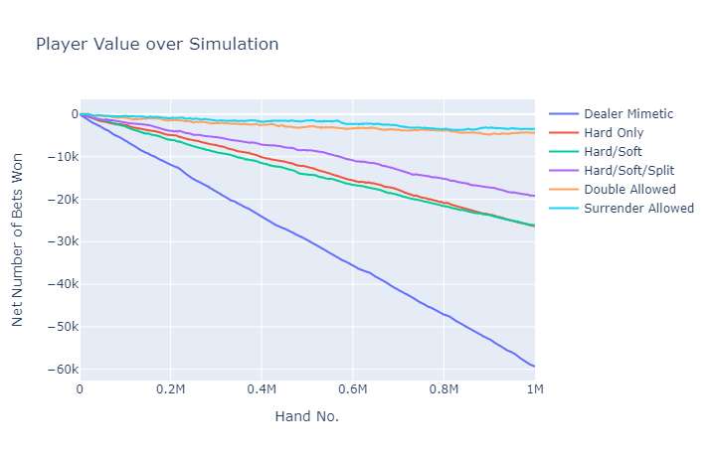

**Appendix E: Card-Combination Realized Values from Optimal Strategy (Disregarding Double-Down)**

*\*All results generated with Blackjack value = 1.5, 1MM hands played, 4/6 decks cut-in, and dealer hits on soft 17s*

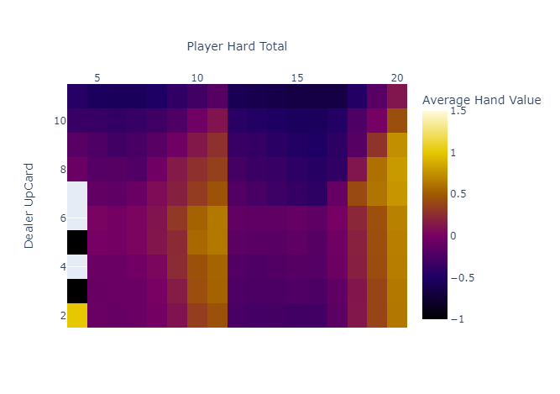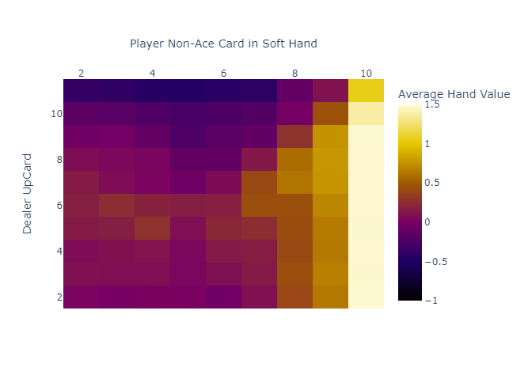

**Appendix F: Optimal Strategy for H17 Game**

*(with probability-weighted differential value from dealer action)***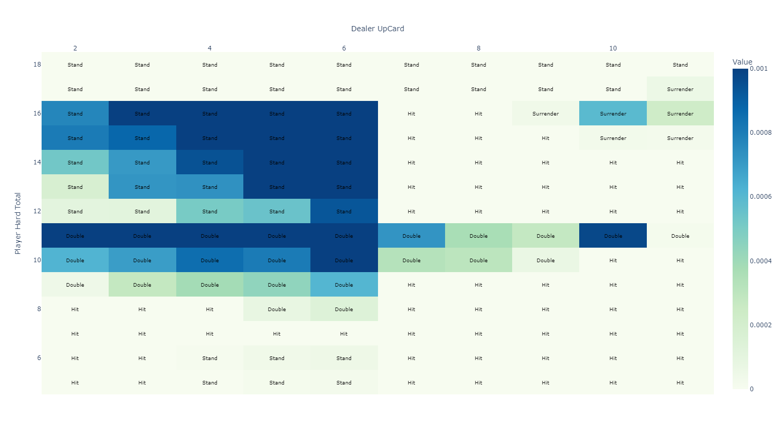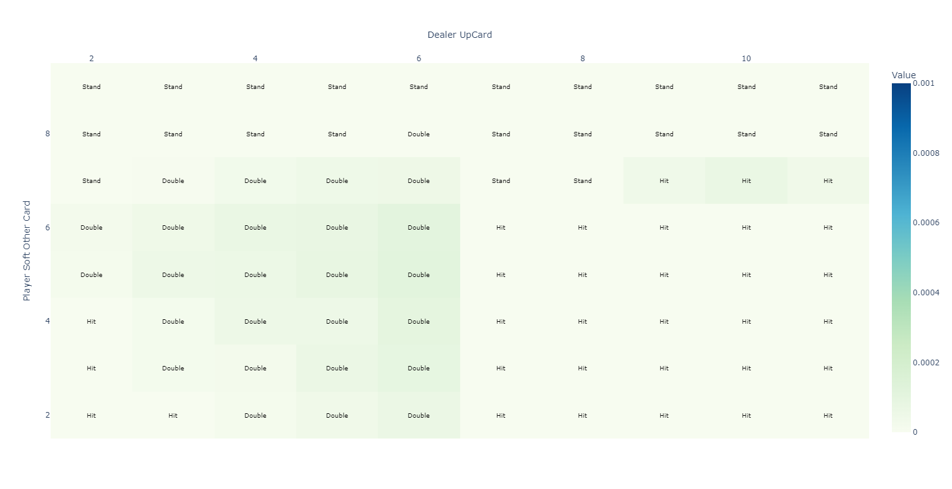**

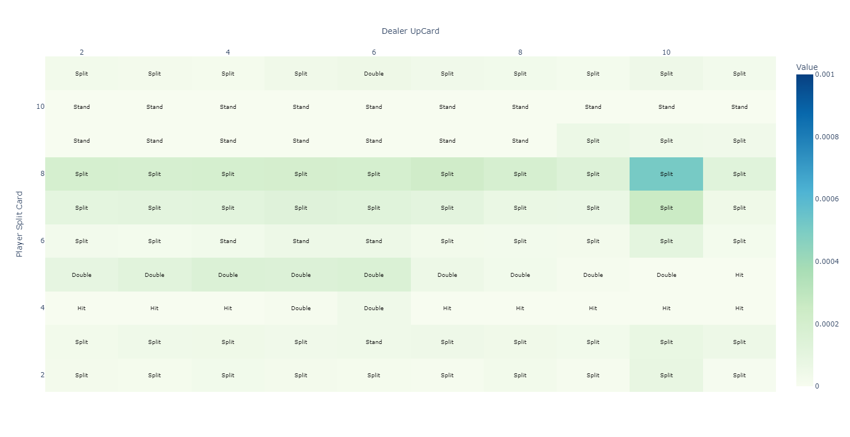

**Appendix G: Optimal Strategy for S17 Game**

*(with probability-weighted differential value from dealer action)***